Rate My Slumlord

Sprint Review Report
Sprint 1
Version 1.2
06/25/2019

Matthew Gabrin, JP Held, Ryan Gabrin
Software Engineer

Prepared for
CS 1530 Software Engineering
Summer 2019
University of Pittsburgh

Revision History

Date | Description | Author | Comments
06/22/19 | Version 1.1 | Gabrin, Gabrin, Held | Initial Revision
06/23/2019 | Version 1.2 | Gabrin, Gabrin, Held | Updates to Specific Goals

Document Approval

The following Software Requirements Specification has been accepted and approved by the following:
Signature | Printed Name | Title | Date
 | Ryan Gabrin | Software Eng. | 6/25/2019
 | Matthew Gabrin | Software Eng. | 6/25/2019
 | John Held | Software Eng. | 6/25/2019

Table of Contents

Revision History ii
Document Approval ii
1. Introduction 1
2. Specific Goals 1
3. AnalTICS 7
4. CONCLUSION 8

1. Introduction
The overall goals for Sprint 1 were to setup the database to maintain all data collected, establish a REACT and Spring framework connection to bind the front and back end of the application, and to begin generating the front-end user interface (UI) of the application. Overall, a total of 11 stories and 27 points were planned for Sprint 1, and of that total __ stories and __ points were ultimately implemented as projected, with __ stories having been started but not completed. Up to this point, the project has a fully established database capable of storing and protecting our application data whilst simultaneously being able to be used for supplying data to calls made from our back-end REST API that is to be developed in Sprint 2. The framework to tie the front and back end code of the application is in place, and a mock UI has been set up for the user homepage. Navigation capability between pages has been established, allowing a user to traverse the numerous pages and access all functionalities of the application once finished.
Overall, this sprint was aimed at setting the groundwork for our application and preparing the structure around which the functionality will be implemented. While tying the front and back end frameworks together posed its challenges, having a cohesive connection between the two already will make development in the future much smoother and reduce the opportunity for refactoring to be required down a great deal. The database structure was tedious to plan and took numerous iterations for us to arrive at a finalized schema. Ultimately, all necessary data relationships have been established and set up. Looking forward, the project’s next phase will be focused on front-end application development styled similarly to that of our finished homepage as well as the implementation of back-end logic for filtering landlords and displaying individual landlord account data when selected.

2. Specific Goals
Below are all stories assigned to Sprint 1 with further clarification regarding their individual progress and purpose.

2.1 Story Name & Number
Spring/React Code Initialization – Story 1.1.1
2.1.1 Story Description:
The goal of this story was ultimately to initialize the starter code and structure of the frameworks and establish a link between the Spring and REACT frameworks to be used for the front and back end capabilities of this application to simplify and centralize code and prepare the application to fully integrate form each end.
2.1.2 Story Acceptance Criterion
This story will be considered complete when it is possible to access both Spring and REACT capabilities from the integrated development environment (IDE).
2.1.3 Story Dependencies
This story is not dependent on any other stories.
2.1.4 Story Challenges
The challenge with this story was unfamiliarity with spring. Lots of documentation was read in order to form a working structure, so most of the time spent on this story was done reading instead of coding. In addition, setting up a node React project with babel to transpile newer Javascript, webpack to bundle, and Bootstrap for premade CSS is non-trivial, as any one misconfiguration could break the whole setup.
2.1.5 Story Assigned to
Matthew Gabrin, Ryan Gabrin
2.1.6 Story Points
3 points were assigned to this story.
2.1.7 Status: Completed or not
Completed

2.2 Story Name & Number
PostgreSQL Database Setup – Story 1.1.2
2.2.1 Story Description:
The goal of this story was ultimately to generate a database capable of storing all necessary data for the sustainable and repeatable use of this application. All relationships and dependencies between data types should be implemented in this generation to ensure proper data flow and output.
2.2.2 Story Acceptance Criterion
This story will be considered complete when the PostgreSQL database is established and able to contain various data types within the required tables.
2.2.3 Story Dependencies
This story is not dependent on any other stories.
2.2.4 Story Challenges
Collecting the information needed to set up the relations proved to take the most amount of time. Learning about how PostgreSQL differs from other SQL based DBMSs also proved a slight challenge.
2.2.5 Story Assigned to
John Held, Ryan Gabrin
2.2.6 Story Points
5 points were assigned to this story.
2.2.7 Status: Completed or not
Completed

2.3 Story Name & Number
Postgres – Moderators Database – Story 1.1.3
2.3.1 Story Description:
This story focuses on generating a database to store all moderator data, including the permissions levels, usernames, and passwords of said moderators. This will be key to ensuring that moderators are able to carry out the jobs assigned to them, while simultaneously allowing one to track assignments for moderators (i.e. reported reviews to be checked).
2.3.2 Story Acceptance Criterion
This story will be considered complete when the PostgreSQL database is capable of maintaining moderator data including login credentials and related reviews to be accessed, removed, or approved.
2.3.3 Story Dependencies
This story is dependent on the completion of Story 1.1.2, focused on setting up the overall PostgreSQL database within which this moderators database will be a sub-division.
2.3.4 Story Challenges
No challenges for this story.
2.3.5 Story Assigned to
JP Held
2.3.6 Story Points
2 points were assigned to this story.
2.3.7 Status: Completed or not
Completed

2.4 Story Name & Number
Postgres – Administrators Database – Story 1.1.4
2.4.1 Story Description:
This story focuses on generating a database capable of storing all administrator data, including login credentials and permissions credentials to ensure only the administrator is able to carry out the jobs of their security tier. This will ensure that no one outside of the administrator themself will be able to have access to all administrator permissions and capabilities.
2.4.2 Story Acceptance Criterion
This story will be considered complete when the PostgreSQL database is capable of maintaining administrator data, including connections with moderators and general users.
2.4.3 Story Dependencies
This story is dependent on the completion of Story 1.1.2, focused on setting up the overall PostgreSQL database within which this administrators database will be a sub-division.
2.4.4 Story Challenges
No challenges for this story.
2.4.5 Story Assigned to
JP Held
2.4.6 Story Points
2 points were assigned to this story.
2.4.7 Status: Completed or not
Completed

2.5 Story Name & Number
Postgres – Reviews Database – Story 1.1.5
2.5.1 Story Description:
This story focuses on generating a database capable of storing all review data, including the various values collected to be used for generating the overall “Slumlord Score” of the landlord associated with the review. This database will also include fields used to track whether or not a review has been reported as well as the number of “likes” and “dislikes” that the review has received. The data stored here will be vital to ensuring all calculated values for each individual landlord are accurate and inclusive of all available data.
2.5.2 Story Acceptance Criterion
This story will be considered complete when the PostgreSQL database is capable of maintaining data for reviews in connection with specified landlords and properties, safely sharing the data between tables as necessary without overlap of users.
2.5.3 Story Dependencies
This story is dependent upon the completion of Story 1.1.2, focused on setting up the overall PostgreSQL database within which the reviews database will be a sub-division.
2.5.4 Story Challenges
Redefining what a review is proved to be a bit of a challenge. This definition is still somewhat in flux and may change as we continue to implement functionality (dependent solely on technological constraints).
2.5.5 Story Assigned to
JP Held, Ryan Gabrin
2.5.6 Story Points
3 points were assigned to this story.
2.5.7 Status: Completed or not
Completed

2.6 Story Name & Number
Postgres – User Database – Story 1.1.6
2.6.1 Story Description:
This story focuses on generating a database capable of storing all user data, including the permissions levels and their distribution to each of the three user types (general user, moderator, and administrator). This will be helpful in implementing safeguards to keep users from changing to an invalid permissions level.
2.6.2 Story Acceptance Criterion
This story will be considered complete when the PostgreSQL database is capable of maintaining user data in connection with reviews and landlords.
2.6.3 Story Dependencies
This story is dependent on the completion of Story 1.1.2, focused on setting up the overall PostgreSQL database within which the user database will be a sub-division.
2.6.4 Story Challenges
No challenges for this story.
2.6.5 Story Assigned to
JP Held
2.6.6 Story Points
1 point was assigned to this story.
2.6.7 Status: Completed or not
Completed

2.7 Story Name & Number
Postgres – Landlord Database – Story 1.1.7
2.7.1 Story Description:
This story will focus on generating a database capable of storing all landlord data, including an identification number to be used to tie landlords to specific reviews and properties, which will then be used to calculate all other data displayed for the landlord. This is crucial to the success of the application, as ensuring reviews are applied to the correct landlord is vital to the proper calculations.
2.7.2 Story Acceptance Criterion
This story will be considered complete when the PostgreSQL database is capable of collecting and maintaining landlord information in connection with specific reviews and properties, while keeping landlord information unique and separate.
2.7.3 Story Dependencies
This story is dependent upon Story 1.1.2, focused on setting up a PostgreSQL database, as this will be a sub-division of that database.
2.7.4 Story Challenges
No challenges for this story.
2.7.5 Story Assigned to
JP Held
2.7.6 Story Points
1 point was assigned to this story.
2.7.7 Status: Completed or not
Completed

2.8 Story Name & Number
Postgres – Database authentication – Story 1.1.8
2.8.1 Story Description:
This story will focus on generating database authentication in order to ensure data security. Through authentication practices permissions will be assigned that will prevent invalid users from making alterations to the data used for the application, protecting it from malicious attempts to corrupt the application.
2.8.2 Story Acceptance Criterion
This story will be considered complete when the PostgreSQL database restricts user interaction and data manipulation based upon permission levels.
2.8.3 Story Dependencies
This story is dependent on Story 1.1.2, focused on setting up the initial PostgreSQL database.
2.8.4 Story Challenges
No challenges for this story.
2.8.5 Story Assigned to
JP Held
2.8.6 Story Points
1 point was assigned to this story.
2.8.7 Status: Completed or not
Completed

2.9 Story Name & Number
React – Home page – Story 1.1.9
2.9.1 Story Description:
This story will be aimed at implementing a homepage for the application where users will be able to begin filtering out landlords and searching for the landlord(s) they are hoping to find. This story will also be heavily focused on style, as this homepage will function as the base from which the rest of the application’s pages will be structured.
2.9.2 Story Acceptance Criterion
This story will be considered complete when the application is able to be run from the command line and, when they have provided the proper URL, the user is able to access the Rate My Slumlord site and immediately views the Rate My Slumlord homepage allowing them to start filtering landlords and input their criteria.
2.9.3 Story Dependencies
This story is dependent upon the completion of Story 1.1.1, focused on setting up the REACT framework, as without this framework the homepage cannot be implemented and ultimately tested.
2.9.4 Story Challenges
The most difficult part about the home page is determining what we wanted to display to the user as they arrived to the web application. In addition, we needed to implement design and functionality of the page at the same time in the form of Bootstrap components and core functionality because leaving one out would add more technical debt for refactoring than just doing it all at once.
2.9.5 Story Assigned to
Ryan Gabrin, Matthew Gabrin
2.9.6 Story Points
2 points were assigned to this story.
2.9.7 Status: Completed or not
Completed.

2.10 Story Name & Number
React – page navigation – Story 1.1.10
2.10.1 Story Description:
This story will focus on providing user-facing controls for navigating from page to page within the application, tying each section together in the front-end. For the user experience, this is of utmost importance, as imperfect page navigation will greatly increase the difficulty of using the application.
2.10.2 Story Acceptance Criterion
This story will be considered complete when a navigation bar is generate to be added to each page of the site, allowing the user to quickly and efficiently navigate the site.
2.10.3 Story Dependencies
This story is dependent on Story 1.1.1, focused on setting up the Spring and REACT frameworks, as those will be the base for establishing the connections between pages necessary.
This story will also depend on Story 1.1.11, focused on establishing the back-end page navigation connections, as the two must work with one another to achieve the desired functionality.
2.10.4 Story Challenges
One of the main benefits of React is its use in creating a single page application. A component only gets re-rendered if its state changes, meaning you don’t need a Spring routing endpoint to get to each page. However, if you make your entire application a single page application, you can sometimes carry too much state, especially when displaying large amounts of data. This slows down your page renders and ultimately makes the single page application slower than traditional whole page refreshes with regular page routing. As a compromise, the structure we’ve created is where each main page will be redirected to a new endpoint based on normal routing procedures, and the inner components will all remain statically located with fetch requests and state changes rendering inner components.
2.10.5 Story Assigned to
Ryan Gabrin, Matthew Gabrin
2.10.6 Story Points
3 points were assigned to this story.
2.10.7 Status: Completed or not
Completed.

2.11 Story Name & Number
Spring – page navigation – Story 1.1.11
2.11.1 Story Description:
This story will focus on providing the back-end controls for navigating from page to page within the application, completing the page-navigation functionality set up in Story 1.1.10. Again, this is vital for ensuring a smooth and simplistic user experience.
2.11.2 Story Acceptance Criterion
This story will be considered complete when the user is able to utilize the front-end navigation bar to traverse the website pages one at a time accurately.
2.11.3 Story Dependencies
This story is dependent on Story 1.1.1, focused on setting up the Spring and REACT frameworks, as those will be the base for establishing connections in the front and back end between pages as necessary.
This story will also depend on Story 1.1.10, focused on establishing the front-end page navigation connections, as the two must work with one another the achieve the desired functionality.
2.11.4 Story Challenges
The technical challenge of this story was getting familiar with how Spring handles routing and how to create new endpoints. After that was figured out, the next difficulty was figuring out how to map it to corresponding React pages. Spring sends data to the html page through a template, so finding a workaround to get the front end aware of the page state was difficult.
2.11.5 Story Assigned to
Matthew Gabrin
2.11.6 Story Points
4 points were assigned to this story.
2.11.7 Status: Completed or not
Completed

3. Analytics

3.1 Sprint/Product Burndown Chart

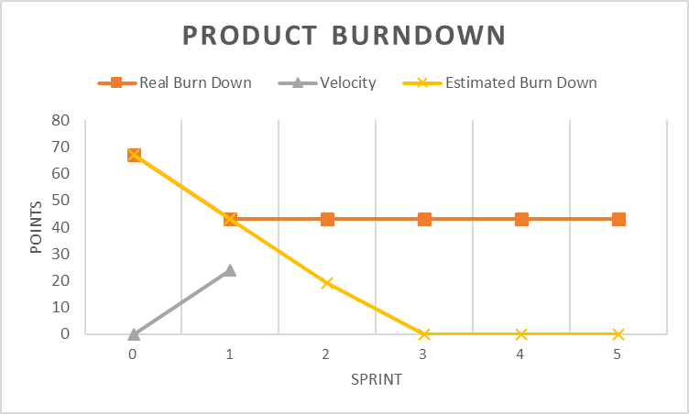

3.2 Sprint Velocity

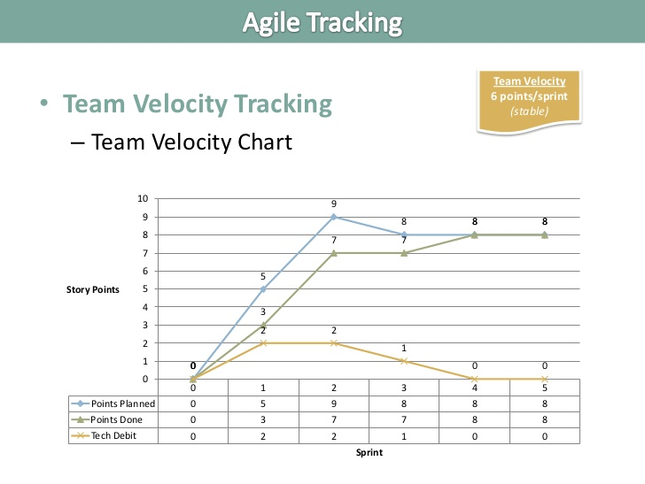

4. Conclusion
Ultimately, this Sprint focused on establishing the framework connections between the front and back end of the application and generating a database to safely and securely store all data required for proper functionality. The first user-facing piece of the application was developed and will act as a model for the style of all other pages on the application in the hopes of increasing visual appeal as well as improving the user experience overall. This Sprint overall was successful in both the quality of work done as well as the scope and amount of work assigned, as our team was able to complete all stories planned to be done in this current sprint.
Look ahead, Sprint 2 will focus more on the front-end REACT/JavaScript creation of a user interface. This is being done next so that while the back-end functionalities are being developed, they can be immediately connected to the front-end attribute to which they will be invoked and testing can be done from a user’s perspective on all aspects of the project (front-end, back-end, and data storage). Given the success of the current sprint and its velocity/burndown charts seen earlier in this document, the amount of work assigned will be approximately the same as this sprint.

